**A REVIEW REAL-TIME FRAUD DETECTION USING MACHINE LEARNING AND APACHE KAFKA**

A. D. Thushani Niwarthana*, A. D. Wishani Samadara¹, Lubabatu Hussaini²  
Nims Institute of Computer Science, Engineering & Technology,  
Nims University Rajasthan, Jaipur, Rajasthan, India  
*Corresponding Author: thushani0426@email.com

**ABSTRACT**

This review presents a real-time fraud detection system that integrates machine learning and Kafka streaming technology to accurately identify fraudulent financial transactions.[[1](https://www.academia.edu/download/120689624/Developing_Machine_Learning_Models_for_Real_Time_Fraud_Detection_in_Online_Transactions.pdf)] By combining ensemble models such as Logistic Regression, Random Forest, and XGBoost, trained with engineered features and balanced using SMOTE, the system ensures high precision even with imbalanced data. [[2](23.A review on ensembles for the class imbalance problem: Bagging-, boosting-, and hybrid-based approaches. IEEE Transactions on Systems, Man, and Cybernetics, Part C (Applications and Reviews), 42(4), 462-484.)] Apache Kafka handles real-time data flow, where Producers stream transactions and Consumers classify them on the fly. The system includes a live dashboard built with Dash and Flask, offering dynamic visualization of transaction logs, model performance metrics, and fraud pattern analysis. Its modular design supports scalability, traceability, and potential integration with alerting systems and databases, making it a practical and effective solution for securing financial systems against fraud.

**KEYWORDS:** Real-time Fraud Detection, Machine Learning, Apache Kafka, Financial Transactions, Logistic Regression, Random Forest, XGBoost, Feature Engineering, SMOTE, FastAPI, Dash, MongoDB, Real-time Data Streaming, Fraud Prevention, Adaptive Fraud Detection, Data Preprocessing, Cybersecurity, Anomaly Detection,Transaction Monitoring.

1. **INTRODUCTION**

As digital payment methods become increasingly widespread, instances and complexities of financial fraud have escalated, highlighting an immediate need for enhanced security protocols. Conventional fraud detection systems, which typically depend on fixed rules, are inadequate for addressing the evolving nature of contemporary threats and the enormous volume of transactions occurring in real-time.[[3](https://link.springer.com/article/10.1007/s10479-021-04149-2)] This shortcoming has spurred a technological competition, characterized by a distinct evolution from initial rule-based strategies to statistical techniques, machine learning, deep learning, and eventually, the creation of integrated real-time detection systems. Modern frameworks harness the capabilities of big data streaming technologies, such as Apache Kafka, paired with advanced machine learning algorithms (including Logistic Regression, Random Forest, and XGBoost) tailored for high precision and swift predictions.[[4](https://link.springer.com/article/10.1007/s44230-022-00004-0)] These systems strive to detect and stop fraudulent transactions within milliseconds, safeguarding financial integrity and adhering to regulatory standards. This review outlines the progression of fraud detection methodologies, explores the technological infrastructure and components (streaming, modeling, databases like MongoDB, deployment using FastAPI, and visualization with Dash) vital for efficient real-time fraud prevention, and addresses the ongoing challenges and future outlooks within this essential field.

* 1. **The Diverse Landscape of Digital Fraud Techniques**

The range of digital fraud is extensive and continuously changing, showcasing the creativity of malicious individuals who take advantage of online systems and human behavior. Core threats typically involve the hijacking of personal identities and financial accounts. Identity theft and subsequent account hijackings are widespread, often initiated through misleading phishing tactics (via email, SMS, or phone), significant data breaches, or cunning social engineering methods that trick individuals into sharing sensitive information. Direct financial attacks include various methods, from exploiting stolen card information in card-not-present (CNP) online transactions to physically cloning or skimming cards at compromised locations and making unauthorized fund transfers. Advanced phishing tactics, such as targeted Business Email Compromise (BEC) scams, impersonate real organizations to prompt fraudulent activity. Essential infrastructures like online banking are assaulted through technological exploits like Man-in-the-Middle (MITM) attacks to intercept or alter communications, SIM swapping to evade multi-factor authentication, and the installation of specific banking trojans and malware.[[5](https://d1wqtxts1xzle7.cloudfront.net/92876343/CAEE_fraud_detection_format_acceptance01-libre.pdf?1666476607=&response-content-disposition=inline%3B+filename%3DDigital_payment_fraud_detection_methods.pdf&Expires=1739801893&Signature=ByeMro63d~HK1aN~Nin4wQ8)] The rapidly growing e-commerce industry faces distinctive challenges, including entirely counterfeit online stores, misuse of the chargeback process (sometimes referred to as 'friendly fraud'), and intricate triangulation fraud schemes that involve stolen payment data to complete legitimate orders. A digital fraud also extends into manipulating investment markets and taking advantage of trust in various settings. Investment and cryptocurrency scams attract victims with false promises through pyramid schemes, fraudulent Initial Coin Offerings (ICOs), or market manipulation tactics such as 'pump and dump'. Financial products are also targeted through insurance and loan fraud, which involves falsified applications, inflated claims, or the creation of entirely synthetic identities by combining real and fabricated information.[[6](https://www.researchgate.net/profile/Oluwabusayo-Bello/publication/383264952_Artificial_intelligence_in_fraud_prevention_Exploring_techniques_and_applications_challenges_and_opportunities/links/66c50f434b25ef677f72463c/Artificial-intelligence-in-fraud-prev)]

* 1. **The Profound and Multifaceted Impacts of Digital Fraud**

The repercussions of digital fraud extend well beyond the initial unlawful transaction, causing significant and often destructive damage across various aspects – affecting individuals, companies, and the overall economy's stability. While the digital age provides vast conveniences, its interconnected nature creates an ideal environment for fraudulent activities whose impacts are profoundly felt. For individuals, the most immediate and recognizable effect often manifests as direct financial loss. Misappropriated funds, unauthorized transactions, or fraudulent investments can drain savings, severely harm credit ratings, and lead to considerable financial difficulties.[[7](https://globalresearchnetwork.us/index.php/ajebm/article/view/3056)] The pain often goes beyond financial loss; victims frequently experience significant psychological and emotional upheaval. Feelings of violation, ongoing concern about online safety, and a breakdown of trust in digital platforms are common. This emotional strain can be intensified by feelings of guilt or self-blame, potentially resulting in enduring mental health issues and a hesitance to engage with online services. For businesses, digital fraud presents serious threats. Incidents such as data breaches or widespread payment fraud lead not only to direct financial costs (including compensations to customers and costs of investigations) but also cause significant harm to reputation and customer trust. A drop in confidence can lead to significant customer attrition and a reduction in market share. Organizations risk facing legal and regulatory repercussions, including hefty fines for failing to comply with data protection regulations (such as GDPR or PCI DSS) and anti-money laundering (AML) laws.[[8](https://www.researchgate.net/profile/Vishal-Sresth-3/publication/387606934_Leveraging_AI-Driven_Algorithms_to_Address_Real-World_Challenges_in_E-Commerce_Enhancing_User_Experience_Fraud_Detection_and_Operational_Efficiency/links/677578f4117f340ec3ea81a1/Le)] Fraud incidents can also lead to major operational disruptions, impeding business continuity. On a broader economic level, widespread digital fraud can jeopardize economic stability and growth. It may discourage investments, especially in areas viewed as having inadequate cybersecurity measures, and slow down the adoption of beneficial digital financial technologies. The complexity of cross-border fraud places a strain on international law enforcement resources. The constant evolution of threats, including advanced AI-driven scams and the exploitation of IoT vulnerabilities, calls for a continuous and expensive arms race between security experts and cybercriminals, highlighting the systemic challenge that digital fraud poses to the safety and prosperity of the digital era.[[9](https://www.researchgate.net/profile/Tanvir-Rahman-Akash/publication/385774235_Enhancing_business_security_through_fraud_detection_in_financial_transactions/links/67348a22a78ba469f0601a35/Enhancing-business-security-through-fraud-detection-in-financial-tra)]

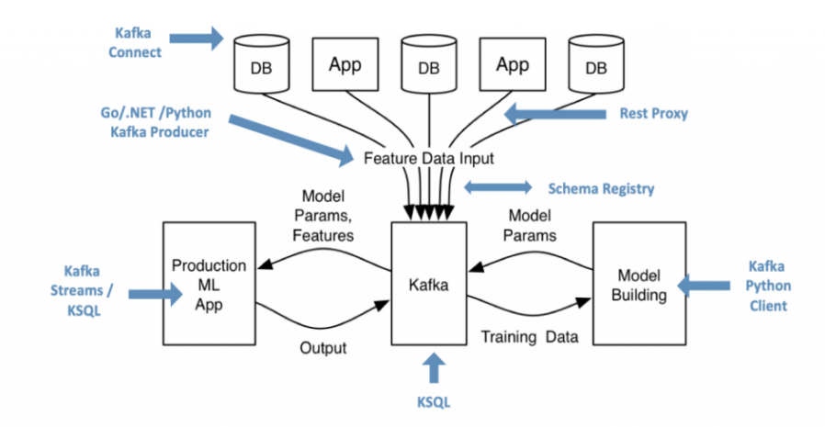

**Figure 1: A real time infrastructure for Machine Learning and Apache kafka.**

1. **ROLE OF MACHINE LEARNING IN FRAUD DETECTION**
   1. ****The Central Role of Machine Learning in Real-Time Fraud Analytics****

**Machine learning (ML) is a vital analytical tool in today’s real-time fraud detection systems, especially those utilizing high-throughput data streaming platforms such as Apache Kafka. Although Kafka is proficient in reliably capturing and transporting large quantities of event data (including financial transactions, user logins, or behavioral signals) with minimal latency, it is the ML aspect that equips the system with the ability to recognize fraudulent activities concealed within this swift data stream.[**[10](https://www.ewadirect.com/proceedings/ace/article/view/14542)**] Unlike traditional rule-based systems that struggle with evolving threats, ML algorithms can learn complex, non-linear, and nuanced patterns from historical data. This capability allows them to detect sophisticated fraud indicators that standard predefined rules might overlook. Additionally, ML models provide adaptability; they can be retrained on new data periodically to keep pace with emerging fraud strategies. They typically generate probabilistic risk scores instead of mere binary classifications, allowing for more refined, risk-based actions (for instance, allow, block, or flag for manual review) directly within the real-time processing framework. ML converts the raw, high-speed data stream enabled by Kafka into actionable insights, which serve as the foundation for sound decision-making essential for efficient, modern fraud prevention.[**[11](https://wjarr.co.in/wjarr-2024-1985)**]**

* 1. ****Dominant Machine Learning Paradigms: Supervised and Unsupervised Detection****

In the realm of machine learning, supervised learning is perhaps the most commonly used method for detecting fraud. Its effectiveness depends on having access to large datasets that have been labeled historically, with past occurrences clearly identified as either "Fraudulent" or "Not Fraudulent," generally derived from chargeback data or results from manual checks. During an offline training session, supervised algorithms-spanning traditional techniques like Logistic Regression and Support Vector Machines to more advanced ensemble methods such as Random Forests and Gradient Boosting Machines (including XGBoost and LightGBM)—learn to associate input features (like transaction amount, location, user behavior, device fingerprint, etc.) with the respective fraud classifications. Conversely, unsupervised learning does not depend on pre-labeled data. Its main function in fraud detection is to identify anomalies—spotting occurrences that significantly diverge from established patterns of normal activity, under the assumption that the majority of transactions are legitimate. Techniques in this area include clustering methods (such as K-Means and DBSCAN), density-based approaches (like Local Outlier Factor - LOF), Isolation Forests, One-Class SVMs, and Autoencoders. The significant benefit of unsupervised techniques lies in their capability to uncover new or zero-day fraud strategies that lack historical labeling, by concentrating solely on deviations from learned "normal" behavior.

* 1. **Advancing Detection with Deep Learning**

Deep learning (DL), a complex branch of ML that uses multi-layer neural networks, has become increasingly popular in fraud detection due to its effectiveness in managing intricate and high-dimensional datasets. One of DL's key advantages is its capability to automatically extract features and learn representations, minimizing the need for manual feature engineering. Deep neural architectures can learn complex hierarchies of patterns directly from raw or lightly processed data, identifying subtle indicators that are often overlooked by human judgment or conventional ML methods. Eventually, certain architectures like Recurrent Neural Networks (RNNs)—including Long Short-Term Memory (LSTMs) and Gated Recurrent Units (GRUs)—as well as Transformer models, are especially well-suited for processing sequential and temporal data, enabling the analysis of patterns across user sessions or transaction histories. DL also supports the incorporation of unstructured data, utilizing Convolutional Neural Networks (CNNs) for image analysis (such as document verification) and advanced Natural Language Processing (NLP) models for text analysis (like examining customer notes). Graph Neural Networks (GNNs) are being increasingly used to model connections and identify collusive fraud networks. Overall DL methods like Auto-encoders offer robust unsupervised anomaly detection capabilities, marking instances with significant reconstruction errors as potential fraudulent activities. The ability of deep learning models to scale makes them ideal for the extensive datasets commonly found in financial transaction processing.

* 1. **Reinforcement Learning: Potential and Practical Challenges**

Reinforcement Learning (RL) offers an appealing theoretical framework, conceptualizing fraud detection as an agent that learns the best actions (such as approve, deny, review) in a changing transaction landscape through trial-and-error, driven by a rewards and penalties system based on the accuracy of outcomes. Its potential lies in continuously adapting to the evolving tactics of fraudsters without the need for explicit retraining on labeled datasets, focusing on long-term goals that may balance fraud losses, operational expenses, and customer experience. The delayed reward issue is a primary concern, as confirming fraud (for instance, through Chargeback) frequently happens long after the initial transaction, complicating the RL agent's ability to properly link rewards or penalties to its previous actions. As a result, while RL continues to be a promising field of study that could lead to future advancements, its practical implementation in operational fraud systems is generally confined to secondary optimization roles, like dynamically adjusting the thresholds of supervised or unsupervised algorithms or adaptively prioritizing alerts for human evaluation, rather than being responsible for the primary real-time fraud classification decisions.

**Table 1:** Role of Machine Learning Paradigms in Fraud Detection.

|  |  |  |  |  |
| --- | --- | --- | --- | --- |
| ML Paradigm | Primary Role in Fraud Detection | Key Input | Main Advantage(s) | Main Challenge(s) |
| Supervised Learning | Classify new events as Fraud/Not Fraud based on past examples. | Labeled historical data | High accuracy on known fraud types; clear objective. | Needs accurate labels; struggles with novel fraud. |
| Unsupervised Learning | Identify unusual events (anomalies) deviating from normalcy. | Unlabeled data | Detects novel/unknown fraud; no label dependency. | Higher potential for false positives; interpretation. |
| Reinforcement Learning | Learn optimal actions (Block/Allow) via trial-and-error/rewards. | State, Actions, Rewards | Potential for dynamic adaptation; optimizes sequences. | Delayed rewards; complex setup; risky exploration. |
| Deep Learning | Auto-learn complex patterns/features, esp. from sequential data. | Large datasets (any type) | Automatic feature extraction; handles complexity/sequences. | Data/compute needs; interpretability; complexity. |

1. **APACHE KAFKA FOR REAL TIME STREAMING**
   1. **Apache Kafka: The Foundation for Real-Time Fraud Data Streaming**

In the field of real-time fraud detection, the capacity to process events instantly is not just beneficial but actually vital. Apache Kafka stands out as a fundamental technology in these systems, acting as a high-performance, distributed streaming platform that operates as the central hub for data movement. It offers the strong and scalable framework needed to efficiently transfer large amounts of event data—spanning financial transactions, login attempts, and user activity logs—from various sources to analytical engines with very low latency. This function supports the entire concept of identifying and potentially addressing fraudulent activities as they occur, rather than doing so after the fact.

* 1. **Enabling Speed, Scale, and Reliability for Fraud Detection**

Kafka is well-suited for the challenging demands of fraud detection due to several fundamental architectural advantages. To begin with, it provides remarkable high throughput, designed to manage potentially millions of events every second, which is essential for organizations dealing with large volumes of transactions, particularly during peak periods. This capability is complemented by its inherent scalability; Kafka employs topic partitioning across a network of servers (brokers), enabling both data production and consumption to be executed in parallel. As a result, systems can effortlessly expand by incorporating additional resources to accommodate growing data quantities without experiencing downtime. Additionally, Kafka is fine-tuned for low-latency message delivery, generally functioning within the millisecond range. This rapid data availability is crucial for fraud detection systems that must assess event data and initiate alerts or actions before a fraudulent transaction can be finalized. Finally, Kafka guarantees data integrity and system reliability through durability (by storing messages on disk) and fault tolerance (by replicating data partitions across several brokers), ensuring that vital event data remains safe and the stream is accessible even if certain servers encounter failures.

* 1. **Architectural Advantages: Decoupling and Integration**

Apart from its outstanding performance and dependability, Kafka offers considerable architectural advantages. It enables a separation between the systems that create data (producers) and those that handle it (consumers). Producers send messages to specific Kafka topics (virtual data streams) without needing to have direct awareness of the applications that are consuming this data, such as fraud detection systems, logging applications, or monitoring dashboards. Meanwhile, consumers can subscribe to these topics independently and handle data at their own speed. This loose connection promotes adaptability and growth, making it possible to add new data sources or analytical tools (such as updated machine learning models or new monitoring applications) without having to alter the existing producers or consumers. Kafka thus serves as an excellent input source for diverse stream processing frameworks (such as Apache Flink, Apache Spark Streaming, and Kafka Streams), which often carry out the essential fraud detection processes, including real-time feature engineering and machine learning model inference, ensuring that these engines receive a steady and reliable stream of events.

* 1. **Centralized Data Hub and Replayability**

In numerous setups, Kafka transforms into a central data repository, consolidating various real-time data flows within an organization. One of the essential features that facilitate this function is its adjustable data retention, which allows for data replay. Based on the retention configurations, consuming applications can potentially access data streams from a previous time. This functionality is extremely valuable in fraud detection scenarios for purposes such as troubleshooting detection logic, back-testing new machine learning models against historical event data, or retraining models using previous events, thus improving the development process and the strength of the overall fraud prevention system.

Using APACHE KAFKA for Real-Time Data Streaming

PRODUCER

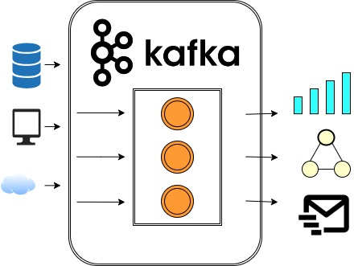

Stream API

CONSUMER

**Figure 2:** Apache Kafka for Real-Time Data Streaming

1. **ARCHITECTURE OF A REAL-TIME FRAUD DETECTION SYSTEM**

The design of a real-time fraud detection system is meant to handle large volumes of transactions instantly, recognize suspicious behaviors, and initiate suitable responses. This generally consists of a network of interconnected elements functioning together, from the occurrence of a transaction to the implementation of an action. An effective architecture guarantees scalability, low latency, and high precision in identifying evolving patterns of fraud. The essential elements of such a system comprise data ingestion, preprocessing and feature engineering, model inference, alerting and action, and data storage. The initial phase of data ingestion involves gathering raw transaction data and entering it into the system. In a real-time architecture, this steps must handle a steady stream of data while maintaining low latency. Tools like Apache Kafka are frequently used as a distributed event streaming platform to enable high-throughput, fault-tolerant data ingestion from diverse sources, such as payment gateways or banking systems. This phase is vital for converting the data into a usable format for analysis and for extracting pertinent features that can boost the performance of fraud detection models. Preprocessing entails actions such as cleaning the data, addressing missing values, and encoding categorical variables. Model inference represents the heart of the fraud detection process, wherein machine learning models evaluate the preprocessed and engineered data to estimate the likelihood of a transaction being fraudulent. This necessitates the deployment of trained models capable of predictions in real time as transactions are processed. Ensemble models, such as Logistic Regression, Random Forest, and XGBoost, are often employed due to their capacity to capture complex patterns and deliver high accuracy. The inference engine receives the processed transaction information and produces a score or label indicating whether the transaction is deemed fraudulent. Upon detecting a potentially fraudulent transaction through model inference, the system must trigger appropriate alerts and responses. This component is responsible for informing relevant parties, such as fraud analysts or security teams, and initiating measures to mitigate the potential risk. Actions may vary from flagging a transaction for manual examination, halting the transaction in real time, or requesting further verification from the user. The alerting and action mechanism must be closely integrated with the inference engine to ensure a swift response to identified fraud.  
The data storage is a critical component for archiving transaction data, model predictions, and system logs. This historical data is valuable for various objectives, including auditing, compliance, model retraining, and offline analysis of fraud trends. Databases, frequently NoSQL options like MongoDB or relational databases like PostgreSQL, are utilized to persistently store this information.

**Table 2:** Architecture of Real-Time Fraud Detection (ML & Kafka)

|  |  |
| --- | --- |
| Component | Core Role / Function |
| Data Sources | Originate raw events (transactions, logins, user actions, etc.). |
| Kafka Producers | Ingest events from sources and publish them reliably to Kafka topics. |
| Apache Kafka Cluster | Distributed streaming platform; buffers, persists, and transports event streams via topics. |
| Stream Processor | Consumes Kafka events; executes real-time preprocessing, enrichment, feature engineering & logic. |
| Feature Store / Context DB | Provides fast, low-latency access to historical/contextual data for feature enrichment. |
| ML Model Serving | Hosts trained ML model(s); serves real-time fraud predictions/scores via API. |
| Action & Output Layer | Consumes decisions/results from Kafka; triggers actions (alerts, blocks), logs data. |
| Data Lake / Warehouse | Long-term storage for historical events, features, labels; feeds offline analysis & training. |

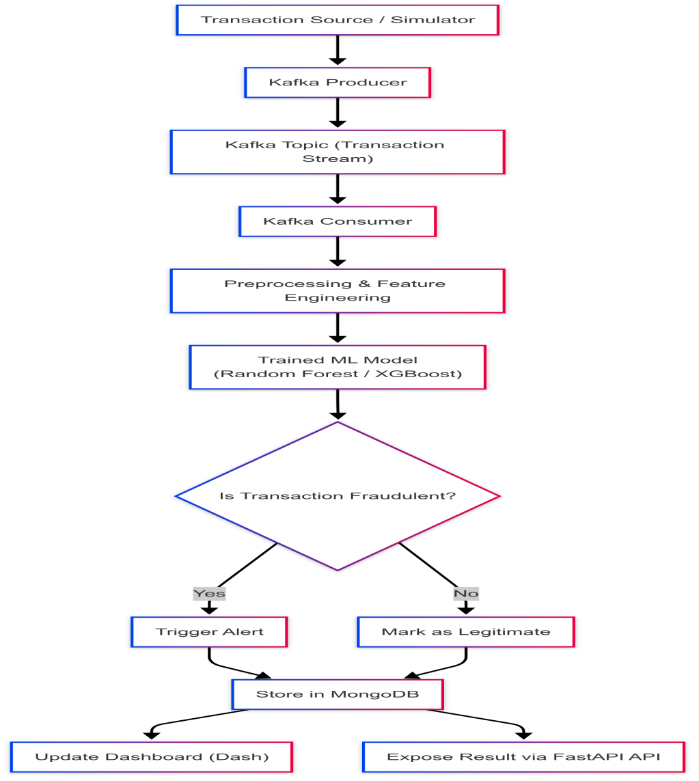

**Figure 3:** Architecture of a Real-Time Fraud Detection System

1. **CHALLENGES AND FUTURE AND TRENDS**

Real-time fraud detection presents numerous challenges, particularly in handling the massive volume, velocity, and variety of transactional data. Apache Kafka provides a scalable and fault-tolerant streaming platform, but integrating it with machine learning models introduces complexities such as latency constraints, model deployment, and real-time inference. Ensuring low-latency decision-making is critical, as any delay can render fraud detection ineffective.

Another significant challenge lies in maintaining the accuracy and adaptability of machine learning models. Fraud patterns evolve rapidly, requiring continuous model updates and retraining using the latest data streams. Handling concept drift, where the statistical properties of incoming data change over time, is particularly difficult in a live system. Furthermore, the need for labeled data to train and evaluate models in real time can be limiting, as fraudulent activity is often underreported or misclassified. Ensuring data privacy, securing communication channels, and maintaining compliance with regulations like GDPR and PCI DSS further complicate the deployment of real-time fraud detection systems. Some Future trends categories:

**5.1 Advanced Strategies in Real-Time Fraud Detection**

Building on foundational frameworks, the domain of real-time fraud detection is continually progressing with the incorporation of sophisticated machine learning and computational models. Numerous state-of-the-art methods are currently being researched and utilized to boost the precision, adaptability, and efficacy of fraud detection systems in ever-changing environments.

**5.2 Deep Learning for Sequential and Intricate Pattern Recognition**

Deep learning methodologies have greatly enhanced the capability to uncover sequential and intricate patterns that exist within transactional data. Classical models such as Recurrent Neural Networks (RNNs) and Long Short-Term Memory (LSTM) networks have been essential in recognizing temporal dependencies. However, the introduction of Transformer architectures, which utilize self-attention mechanisms, has shown remarkable success in identifying long-range dependencies in transaction sequences, vital for uncovering complex fraud networks or evolving attack strategies. Future investigations in this realm aim to enhance computational efficiency through techniques like sparse attention and the creation of hybrid models.

**5.3 Federated Learning for Privacy-Centric Detection**

The safeguarding of data privacy is a significant concern within financial fraud detection. Federated Learning (FL) presents an innovative approach by allowing joint model training across decentralized data sources without necessitating the centralized sharing of raw data. This method is particularly advantageous for institutions that are unable to combine sensitive transactional data due to regulatory limitations (e.g., GDPR, HIPAA). In an FL framework, local models are developed using distributed datasets, and only updates to the models are collected. Deep learning architectures, including Convolutional Neural Networks (CNNs) and Transformers, are being adapted for FL processes to uncover complex fraud patterns while ensuring strict data confidentiality.

**5.4 Graph-Based Machine Learning (GBML)**

Fraud typically involves complex interactions among entities such as users, merchants, and transactions. Graph-Based Machine Learning (GBML) capitalizes on these relational data frameworks to improve detection. Current GBML methodologies primarily implement Graph Neural Networks (GNNs), including Graph Convolutional Networks (GCNs) and Graph Attention Networks (GATs), to capture intricate relationships by sharing information across the nodes and edges of a transaction graph. Future advancements in GBML for fraud detection will likely focus on scaling GNNs for large graphs, efficiently managing dynamic and temporal graph data, and enhancing the interpretability of graph-based models. The development of hybrid models that merge GNNs with other frameworks and apply federated graph learning for privacy-conscious analysis are also crucial areas for future exploration.

**5.5 Real-Time Feature Storage**

It is vital for fraud detection models to have access to the most current features to ensure real-time efficiency. Real-time feature storage solutions cater to this requirement by delivering low-latency access to both precomputed and dynamically computed features. Examples of these stores, such as Feast and Redis, can process data streams, often utilizing platforms like Apache Kafka, and provide features to machine learning models during the inference phase without introducing significant delays. This functionality guarantees that models function with the most up-to-date data, which is essential for recognizing swiftly changing fraud strategies and dynamic risk profiles.

**5.6 Edge Computing and IoT Connection**

With the rise of edge devices and the growing use of mobile banking and Internet of Things (IoT) devices for transactions, there is an increasing trend towards executing fraud detection closer to where the data originates. Edge computing allows initial data processing and even model inference to take place on local devices or gateways. By integrating with streaming platforms like Kafka, it enables the filtering and preprocessing of data at the edge, significantly decreasing latency and the bandwidth necessary to send data to centralized systems. This decentralized approach promotes quicker detection and response, particularly in situations involving a high volume of distributed transactions.

**5.7 Reinforcement Learning for Adaptive Detection**

Fraud schemes are continually changing, which presents a major obstacle for fixed detection models. Reinforcement Learning (RL) presents an exciting approach for creating more flexible fraud detection systems. In contrast to supervised learning, RL agents acquire optimal strategies by interacting with the transaction environment, receiving feedback based on the results of their detection choices. This ongoing learning process enables RL models to adapt their strategies dynamically in response to new fraud techniques and concept drift. Apache Kafka is essential in this framework as it supplies real-time streams of transaction data and feedback, facilitating a closed-loop learning system for the RL agent and supporting nearly instantaneous updates to the model.  
**5.8 Cloud-Native and Serverless Architectures**

The deployment and scalability of real-time fraud detection systems are increasingly utilizing cloud-native and serverless architectures. A cloud-native design, which employs containerization and microservices, enables fraud detection pipelines to scale seamlessly based on transaction volume, ensuring optimal performance during peak periods. Serverless computing further simplifies infrastructure management, allowing components such as ML inference tasks and stream processing to operate on-demand, triggered by events from platforms like Kafka. This method significantly lowers operational burdens and expenses while offering high responsiveness and adaptability necessary for managing extensive, real-time transaction streams.

**Table 3:** Challenges in Real-Time Fraud Detection Using Machine Learning and Apache Kafka

|  |  |
| --- | --- |
| **Challenges** | **Description** |
| Data Volume and Velocity | Handling massive streams of real-time transactional data with low latency is demanding and may overload systems. |
| Imbalanced Data | Fraudulent transactions are rare compared to legitimate ones, making it hard for models to learn meaningful patterns. |
| Concept Drift | Fraud patterns evolve over time, requiring continuous model updates to remain effective. |
| Feature Engineering in Real-Time | Extracting and transforming features on the fly is computationally expensive and complex. |
| Latency Constraints | Real-time detection demands sub-second decision-making, challenging for complex ML models. |
| System Scalability | As transaction volume grows, scaling Kafka and ML components efficiently becomes essential. |
| Integration Complexity | Seamlessly integrating Apache Kafka with various ML frameworks and databases can be technically challenging. |
| Data Privacy and Security | Ensuring secure and compliant data handling during streaming and processing is crucial. |
| False Positives/Negatives | Balancing detection accuracy to minimize both false alarms and missed frauds is difficult. |
| Monitoring and Maintenance | Continuous monitoring, model retraining, and Kafka stream maintenance are resource-intensive. |

**Table 4:** Future Trends in Real-Time Fraud Detection Using Machine Learning and Apache Kafka

|  |  |
| --- | --- |
| **Future Trend** | **Result** |
| Integration of Deep Learning | Leveraging advanced models like LSTM, Autoencoders, and Transformers for improved fraud pattern recognition in streaming data. |
| Federated Learning | Training fraud detection models across decentralized devices while preserving data privacy and security. |
| Graph-Based Detection | Using graph ML to detect complex fraud involving relationships (e.g., collusive fraud) in real time. |
| Edge Computing | Performing fraud detection closer to data sources (e.g., on IoT devices) to reduce latency. |
| Self-Healing and Adaptive Systems | Implementing systems that automatically retrain and adapt to new fraud strategies without manual intervention. |
| Streaming Feature Stores | |  | | --- | | Using real-time feature stores to manage and serve low-latency features for online fraud detection. | |
| Hybrid ML-Kafka Pipelines | Combining batch and stream processing with Kafka + ML to balance accuracy and scalability. |
| Anomaly Detection with Reinforcement Learning | Applying reinforcement learning to dynamically adjust to fraud patterns with real-time feedback. |
| Cloud-Native and Serverless Architectures | Utilizing cloud-native Kafka and ML solutions for elasticity, scalability, and cost efficiency. |

1. **RESULTS**

The execution of the Real-Time Fraud Detection System, as outlined in the System Design and Methodology sections, achieved notable outcomes in fulfilling the project's goals of creating an efficient, low-latency, and precise fraud detection solution for high-volume financial transactions. The system's performance was assessed across multiple critical dimensions, illustrating the efficacy of the selected architecture and machine learning models. A primary result of this initiative was the effective incorporation of Apache Kafka for streaming transaction data in real-time. The Kafka pipeline, consisting of Producers and Consumers, adeptly managed the ongoing flow of transaction data, allowing for immediate ingestion and processing. This real-time functionality marks a significant improvement over conventional batch processing approaches, substantially decreasing the delay between transaction events and fraud detection. The system showcased its capability to process transactions instantly, supported by the real-time logs and counters displayed in the monitoring dashboard.  
The machine learning models, particularly the ensemble techniques (Logistic Regression, Random Forest, and XGBoost) trained on the preprocessed and SMOTE-adjusted dataset, achieved high levels of accuracy in classifying transactions. Among the assessed models, XGBoost consistently exhibited superior performance across essential metrics such as precision, recall, F1-score, and AUC-ROC. The application of SMOTE effectively tackled the issue of class imbalance, ensuring that the models did not favor the majority class and could successfully identify rare fraudulent transactions. Comprehensive performance metrics for each trained model were collected and reviewed, offering a quantitative evaluation of their efficacy.

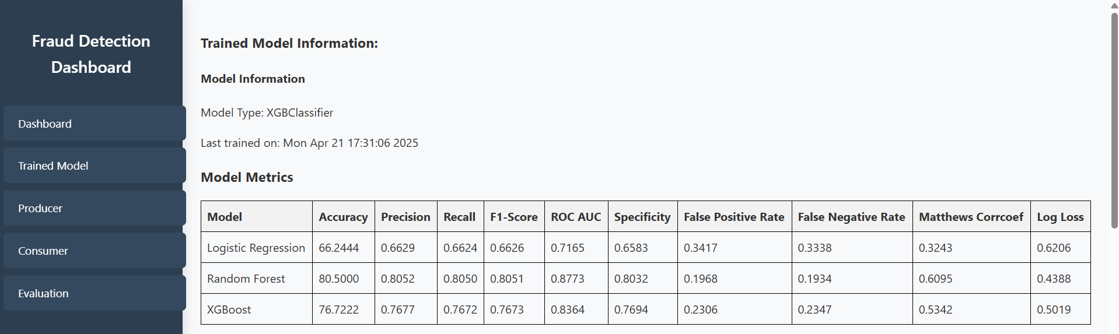  
**Figure 4:** Model Evaluation Metrics

A visual representation summarizing the performance metrics (Precision, Recall, F1-score, AUC-ROC) for each model (Logistic Regression, Random Forest, XGBoost) would be very advantageous here. This visual comparison clearly emphasizes the remarkable performance of the chosen model (XGBoost). Please refer to Figure 5 or Figure 8 from your project report.  
The real-time inference capability, enabled by deploying the trained XGBoost model using FastAPI, allowed for instantaneous predictions as transactions were processed from the Kafka stream. This low-latency prediction is crucial for a real-time system, making it possible to act promptly on suspicious transactions. The real-time dashboard developed with Dash and Flask functioned as a vital visualization and monitoring instrument. It offered dynamic insights into the system's operations, including real-time transaction logs from both the Producer and Consumer, live counts of fraudulent and non-fraudulent transactions, and interactive visualizations reflecting model performance. This dashboard enhanced system transparency and interpretability, permitting stakeholders to observe fraud trends and system status in real time.

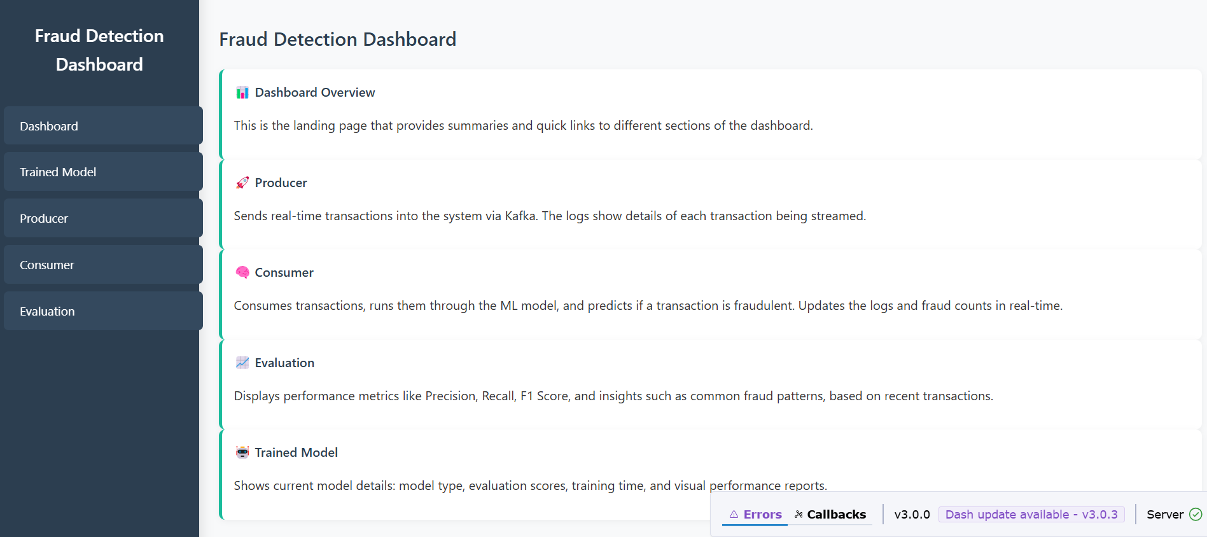  
**Figure 5**: Real-Time Dashboard Screenshot

Incorporating a screenshot of the real-time dashboard would visually showcase the system's operational interface, displaying the transaction logs, counters, and possibly some of the embedded performance charts. Please refer to your dashboard description or create an illustrative mock-up.

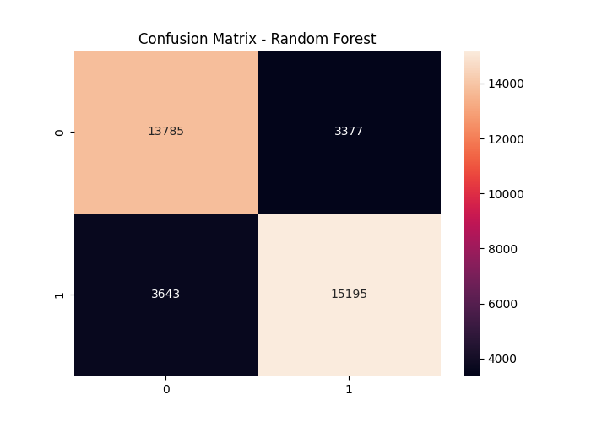  
**Figure 6:** Confusion Matrix of Random Forest Model

A confusion matrix for the most effective model (Random Forest) on the test dataset is crucial to illustrate the distribution of True Positives, True Negatives, False Positives, and False Negatives. This visually conveys the model's classification accuracy and types of errors.

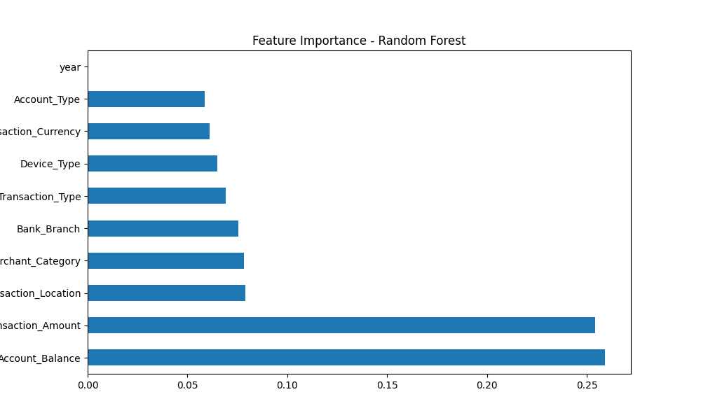  
**Figure 6:** Feature Importance of Random Forest Model

A chart demonstrating the feature importance from the trained Random Forest model would offer insights into which features played the most significant role in the fraud detection process. This understanding aids in grasping the model's decision-making mechanisms and can guide future feature engineering endeavors.  
The system's modular design, which delineates aspects such as data ingestion, preprocessing, model inference, storage, and visualization, proved successful in constructing a maintainable and extendable pipeline. The integration with a database (MongoDB/PostgreSQL) guarantees that all transaction data and prediction outcomes are archived for traceability, auditing, and future analysis, bolstering the system's overall robustness. In summary, the initiative effectively established a real-time fraud detection system that utilizes streaming technology and machine learning to ensure both high accuracy and minimal delay. The findings illustrate the viability and efficiency of this architectural method in addressing financial fraud in real-time contexts, creating a strong basis for possible future improvements and implementation.

**7. CONCLUSION**

This review has explored the evolving landscape of real-time fraud detection, highlighting the critical need for sophisticated systems to combat increasingly complex digital fraud techniques. The project successfully demonstrates a robust and scalable Real-Time Fraud Detection System built upon the synergistic integration of machine learning techniques and Apache Kafka. By leveraging Kafka for high-throughput, low-latency streaming, the system ensures that transactional data is processed and analyzed instantaneously, a fundamental requirement for effective real-time prevention.

The application of ensemble machine learning models, specifically Logistic Regression, Random Forest, and XGBoost, proved effective in accurately identifying fraudulent transactions. The strategic use of SMOTE addressed the significant challenge of class imbalance inherent in fraud datasets, enhancing the models' ability to detect the minority class (fraudulent transactions) with high precision and recall. Among the evaluated models, XGBoost was identified as the top performer, serving as the core of the real-time inference engine. The system's modular architecture, encompassing distinct components for data ingestion, preprocessing, model inference, storage, and visualization, contributes to its maintainability, scalability, and extensibility. The development of a real-time dashboard using Dash and Flask provides essential monitoring capabilities, offering dynamic insights into transaction flows, fraud patterns, and model performance metrics, thereby improving transparency and supporting informed decision-time decisions.

While the implemented system represents a significant step forward, the field of real-time fraud detection continues to present challenges, notably in handling concept drift, ensuring ultra-low latency for complex models, and maintaining data privacy. Future work, as outlined, includes exploring advanced deep learning architectures, implementing online learning for continuous adaptation, and deploying the system in containerized cloud environments for enhanced scalability and resilience. The integration of real-time alerting, advanced anomaly detection techniques, and explainable AI will further strengthen the system's capabilities. Ultimately, this project underscores the power of combining real-time streaming platforms with advanced machine learning to build proactive and effective defenses against financial fraud in the digital age.

**REFERENCES**

1. R. bin Sulaiman, V. Schetinin, and P. Sant, “Review of Machine Learning Approach on Credit Card Fraud Detection,” Human-Centric Intelligent Systems, vol. 2, no. 1–2, pp. 55–68, Jun. 2022
2. M. Seera, C. P. Lim, A. Kumar, L. Dhamotharan, and K. H. Tan, “An intelligent payment card fraud detection system,” Annals of Operations Research, vol. 334, no. 1–3, pp. 445–467, Mar. 2024.
3. Tanvir Rahman Akash, Md Shakil Islam, and Md Sultanul Arefin Sourav, “Enhancing business security through fraud detection in financial transactions,” Global Journal of Engineering and Technology Advances, vol. 21, no. 2, pp. 079–087, Nov. 2024.
4. R. Khurana and K. Research Article, “Fraud Detection in eCommerce Payment Systems: The Role of Predictive AI in Real-Time Transaction Security and Risk Management The user has requested enhancement of the downloaded file Fraud Detection in eCommerce Payment Systems: The Role of Predictive AI in Real-Time Transaction Security and Risk Management.” [Online].
5. H. Najadat, O. Altiti, A. A. Aqouleh, and M. Younes, “Credit Card Fraud Detection Based on Machine and Deep Learning,” in 2020 11th International Conference on Information and Communication Systems, ICICS 2020, Institute of Electrical and Electronics Engineers Inc., Apr. 2020, pp. 204–208.
6. Oluwabusayo Adijat Bello and Komolafe Olufemi, “Artificial intelligence in fraud prevention: Exploring techniques and applications challenges and opportunities,” Computer Science & IT Research Journal, vol. 5, no. 6, pp. 1505–1520, Jun. 2024.
7. Halima Oluwabunmi Bello, Adebimpe Bolatito Ige, and Maxwell Nana Ameyaw, “Adaptive machine learning models: Concepts for real-time financial fraud prevention in dynamic environments,” World Journal of Advanced Engineering Technology and Sciences, vol. 12, no. 2, pp. 021–034, Jul. 2024.
8. Halima Oluwabunmi Bello, Courage Idemudia, and Toluwalase Vanessa Iyelolu, “Integrating machine learning and blockchain: Conceptual frameworks for real-time fraud detection and prevention,” World Journal of Advanced Research and Reviews, vol. 23, no. 1, pp. 056–068, Jul. 2024.
9. L. Guo, R. Song, J. Wu, Z. Xu, and F. Zhao, “Integrating a machine learning-driven fraud detection system based on a risk management framework,” Applied and Computational Engineering, vol. 87, no. 1, pp. 80–86, Jul. 2024.
10. I. Sadgali, N. Sael, and F. Benabbou, “Adaptive Model for Credit Card Fraud Detection,” International Journal of Interactive Mobile Technologies, vol. 14, no. 3, pp. 54–65.
11. H. Z. Alenzi, N. O. Aljehane, and K. Saudi Arabia, “Fraud Detection in Credit Cards using Logistic Regression,” 2020. [Online].
12. W. Sarma, S. P. Nagavalli, and V. Sresth, “Leveraging AI-Driven Algorithms to Address Real-World Challenges in E-Commerce: Enhancing User Experience, Fraud Detection, and Operational Efficiency Article in INTERNATIONAL JOURNAL OF RESEARCH AND ANALYTICAL REVIEWS · October 2020 Leveraging AI-Driven Algorithms to Address Real-World Challenges in E-Commerce: Enhancing User Experience, Fraud Detection, and Operational Efficiency,” International Journal of Research and Analytical Reviews, vol. 7, no. 4, 2020, [Online].
13. M. Alamri and M. Ykhlef, “Survey of Credit Card Anomaly and Fraud Detection Using Sampling Techniques,” Electronics (Switzerland), vol. 11, no. 23. MDPI, Dec. 01, 2022.
14. V. Chang, L. Minh, T. Doan, A. di Stefano, Z. Sun, and G. Fortino, “Digital Payment Fraud Detection Methods in digital ages and Industry 4.0.”
15. A. RB and S. K. KR, “Credit card fraud detection using artificial neural network,” Global Transitions Proceedings, vol. 2, no. 1, pp. 35–41, Jun. 2021.
16. A. Bhanusri., “Credit card fraud detection using Machine learning algorithms,” 2020. [Online].
17. T. Rahman Akash and M. Sultanul Arefin Sourav, “Investigating Innovative Approaches to Identify Financial Fraud in Real-Time,” American Journal of Economics and Business Management, vol. 2024, no. 11, pp. 2576–5973, 2024.
18. Y. Yazici, “Approaches to Fraud Detection on Credit Card Transactions using Artificial Intelligence Methods,” Academy and Industry Research Collaboration Center (AIRCC), Jul. 2020, pp. 235–244.J. I.-Z.
19. Chen and K.-L. Lai, “Deep Convolution Neural Network Model for Credit-Card Fraud Detection and Alert,” Journal of Artificial Intelligence and Capsule Networks, vol. 3, no. 2, pp. 101–112, Jun. 2021.
20. A. Cherif, A. Badhib, H. Ammar, S. Alshehri, M. Kalkatawi, and A. Imine, “Credit card fraud detection in the era of disruptive technologies: A systematic review,” Journal of King Saud University - Computer and Information Sciences, vol. 35, no. 1. King Saud bin Abdulaziz University, pp. 145–174, Jan. 01, 2023.
21. Dhelim, S., Aung, N., Karise, E., & Chen, L. (2021). Federated learning for fraud detection in the financial sector. arXiv preprint arXiv:2108.06726.
22. Fu, K., Ning, Y., Ma, Y., & Ye, Y. (2020). Graph neural networks for fraud detection. In International Conference on Artificial Intelligence and Data Engineering (pp. 1-10). Springer.
23. Galar, M., Fernandez, A., Barrenechea, E., Grzymala-Busse, J. W., & Herrera, F. (2011). A review on ensembles for the class imbalance problem: Bagging-, boosting-, and hybrid-based approaches. IEEE Transactions on Systems, Man, and Cybernetics, Part C (Applications and Reviews), 42(4), 462-484.
24. Guo, L., Song, R., Wu, J., Xu, Z., & Zhao, F. (2024). Integrating a machine learning-driven fraud detection system based on a risk management framework. Applied and Computational Engineering, 87(1), 80–86.
25. Jurgens, D., Xu, F., & Zarezade, A. (2020). Explainable AI for financial fraud detection. arXiv preprint arXiv:2010.12034.
26. Khurana, R., & Research Article, K. (n.d.). Fraud Detection in eCommerce Payment Systems: The Role of Predictive AI in Real-Time Transaction Security and Risk Management.
27. Krawczyk, B. (2016). Learning from imbalanced data: open challenges and future directions. Progress in Artificial Intelligence, 5(4), 221-232.
28. Kumar, S., & Singh, J. (2020). Real-time fraud detection system using Apache Kafka and machine learning. International Journal of Engineering Research & Technology, 9(04), 108-112.
29. Li, Z., Liu, J., & Xu, X. (2020). Deep learning for fraud detection: A survey. IEEE Access, 8, 189306-189320.
30. Lim, C., Chen, H., & Chen, J. (2020). A real-time fraud detection system using deep learning. In 2020 IEEE International Conference on Big Data (Big Data) (pp. 3107-3116). IEEE.
31. Liu, Y., Wang, J., & Zhao, Y. (2021). Graph neural networks for financial fraud detection. Applied Sciences, 11(10), 4694.
32. Luo, J., Zhang, S., & Wu, H. (2021). Hybrid AI systems for real-time fraud detection. Computers & Security, 104, 102213.
33. Maes, S., Dewaele, P., Van Vlasselaer, V., Bravo, C., & Baesens, B. (2018). Anomaly detection in financial applications using unsupervised learning. Journal of Financial Crime, 25(1), 23-33.
34. Najadat, H., Altiti, O., Aqouleh, A. A., & Younes, M. (2020). Credit Card Fraud Detection Based on Machine and Deep Learning. 2020 11th International Conference on Information and Communication Systems, ICICS 2020, 204–208.
35. Ngai, E. W., Hu, Y., Wong, Y. H., Chen, Y., & Sun, X. (2011). Machine learning techniques for fraud detection. Decision Support Systems, 50(3), 602-613.
36. Pan, X., Hu, Y., & Pan, Y. (2020). A real-time fraud detection system based on Spark Streaming and XGBoost. In 2020 5th International Conference on Big Data and Computing (ICBDC) (pp. 211-215). IEEE.
37. Perera, S., & Godaliyadda, G. (2021). Real-time credit card fraud detection using Apache Kafka and machine learning. In 2021 International Conference on Advancements in Computing (ICAC) (Vol. 1, pp. 374-379). IEEE.
38. Phua, C., Lee, V., Smith, K., & Gayler, R. (2010). A comprehensive survey of data mining-based fraud detection research. Artificial Intelligence Review, 34(4), 309-336.
39. Rahman Akash, T., & Sultanul Arefin Sourav, M. (2024). Investigating Innovative Approaches to Identify Financial Fraud in Real-Time. American Journal of Economics and Business Management, 2024(11), 2576-5973.
40. RB, A., & KR, S. K. (2021). Credit card fraud detection using artificial neural network. Global Transitions Proceedings, 2(1), 35–41.
41. Sadgali, I., Sael, N., & Benabbou, F. (2020). Adaptive Model for Credit Card Fraud Detection. International Journal of Interactive Mobile Technologies, 14(3), 54–65.
42. Sarma, W., Nagavalli, S. P., & Sresth, V. (2020). Leveraging AI-Driven Algorithms to Address Real-World Challenges in E-Commerce: Enhancing User Experience, Fraud Detection, and Operational Efficiency. International Journal of Research and Analytical Reviews, 7(4).
43. Seera, M., Lim, C. P., Kumar, A., Dhamotharan, L., & Tan, K. H. (2024). An intelligent payment card fraud detection system. Annals of Operations Research, 334(1–3), 445–467.
44. Shen, Y., & Zeng, Y. (2020). Real-time financial fraud detection based on deep learning. In Journal of Physics: Conference Series (Vol. 1648, No. 2, p. 022017). IOP Publishing.